GRAND CAPITAL THALAWATHUGODA MIXED DEVELOPMENT PROJECT

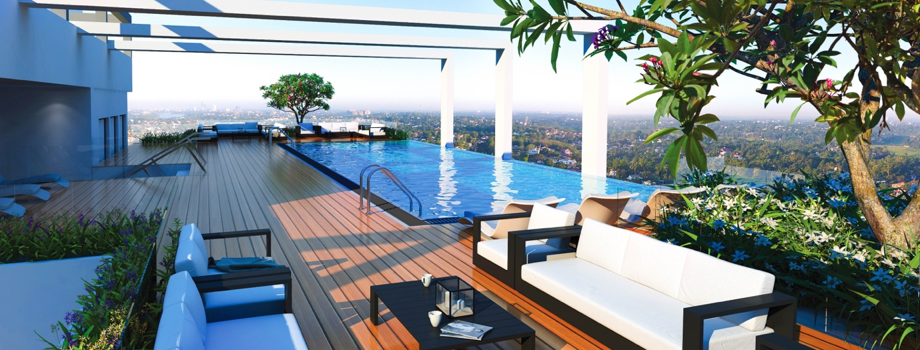
BACKGROUND OF THE PROJECT
Grand Capital Mixed development project is located in Thalawathugoda, Colombo district, which
is from the western province of Sri Lanka. This is a highly residential area. This project consists
of 48 service apartments, restaurants, banquet halls and 42 hotel rooms. Government approvals
are now in the final stages. Already an investment of USD 2.5m has been made by the existing
shareholders.

APPROVALS –
Central Environment Authority
Condominium Management Authority
Local Authority

LAND OWNER | LOCAL PRIVATE
PROJECT | MIXED DEVELOPMENT PROJECT
LOCATION | PANNIPITIYA ROAD, THALAWATHUGODA
 | LOCATED ON THE MAIN ROAD – WITH ROAD FRONTAGE
AREA | 91 perch land
INVESTMENT REQUIREMENT | USD 22m
NO OF APARTMENTS | 46
NO OF HOTEL ROOMS | 42
LEVELS | 12
APPROVALS | IN THE FINAL STAGES OF APPROVAL
WORK DONE | PILING STARTED

OWNERSHIP TYPE | FREE HOLD LAND
PROJECT PERIOD | 4 YEARS
OTHER FEATURES | INIFINITY POOL, ROOF TOP GARDEN, GYMNASIUM, LOUNGE

CONTACT PERSON | Mr. A.W. Warnakula – Chairman  Email – awwarnakula@gmail.com
 | TP – 00 94 777 365335

STRONG PLUS POINTS OF THE PROJECT
- This area is been developing at a very fast pace, as it is just outside Colombo city limits, and also due to high population growth, which are very closer to all main schools, government offices, super markets and hospitals etc.
- This was a project with investments made on the purchase of land and basic requirements such as construction of material stores & office complex, surveys done, clearing of land, boundary lines demarcations, architectural work, engineering drawings, part of piling work and all approvals.
- Apart from the above this project is financially designed to first complete the project and then to commence selling to attract more customers as the market is now spoiled by delays in construction.
- Since a bank guarantee is offered for the safety of the investor, there is no risk to the investor.

