**KATUNAYAKE PROJECT**

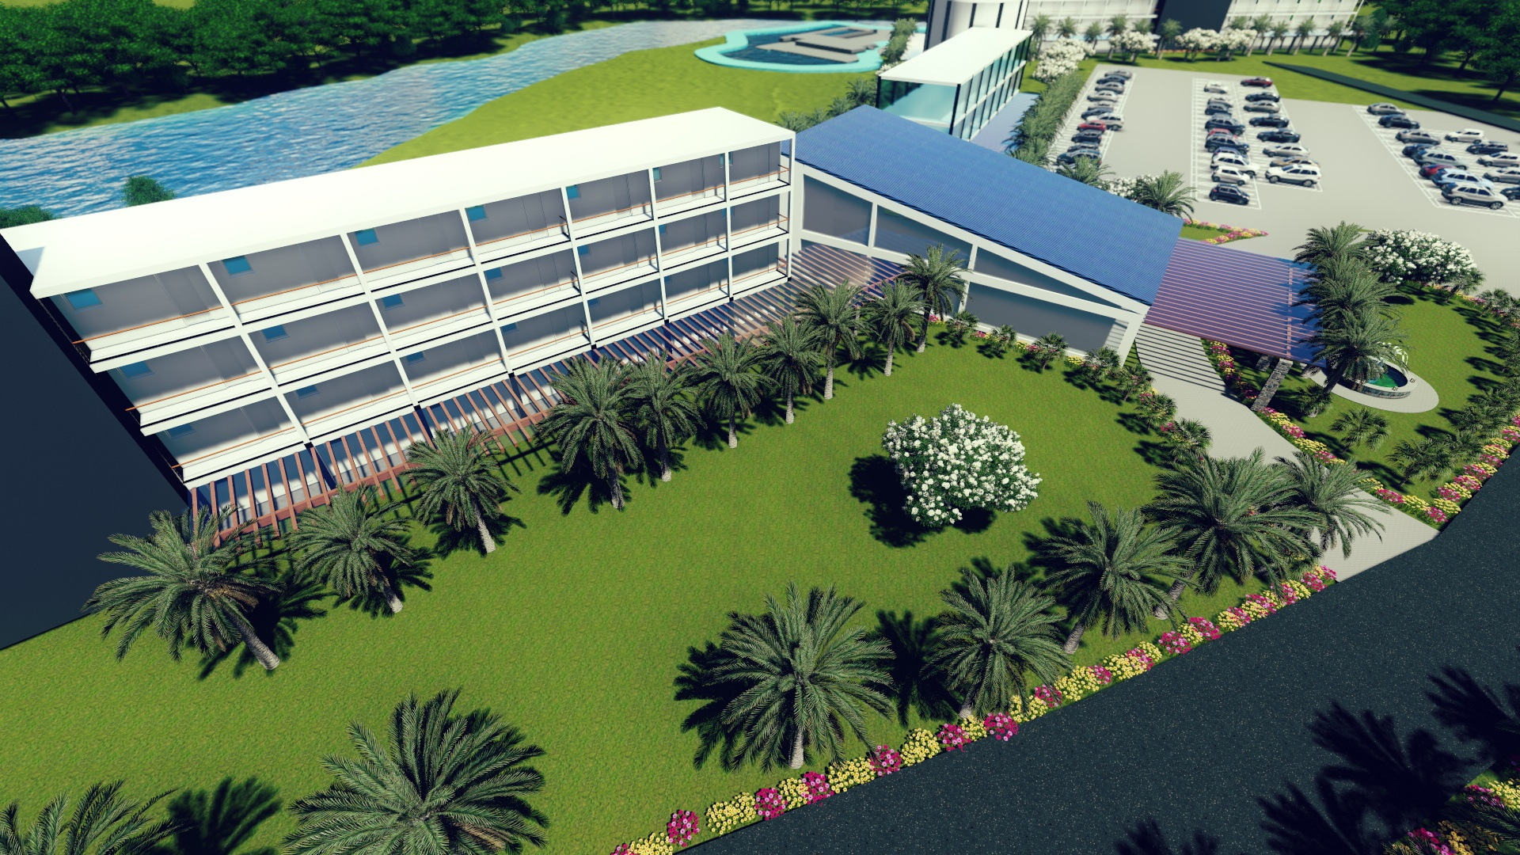

This is top class hospitality management project opposite the Colombo International Airport. The land extent is six acres and located in front of a beautiful water stream. The project is owned by a top-level international non-governmental organization. This training center and business convention center were partly completed, and the balance needs to be completed. This complex was to be used as an international convention center for business, a training center and to house a disaster management control center. They didn't complete the construction, due to unavoidable reasons, and later decided to form a joint venture with a private investor to complete balance part of the project.

Therefore, we are about to finalize a joint venture company with the owner of this project to run the training center and the hospitality management project. Unlike any other hotel in Sri Lanka, this project would get a huge publicity as this is located near the airport and also because project would be jointly run with a reputed intentional organization known the world over. This project was designed mainly for MICE tourism to conduct conventions, training, seminars and for the accommodation of cabin crew of many airlines visiting Katunayake International Airport.

There is a list of top-class hospitality management companies, ready to manage the complex. We intend to handed over this project, to a party who could do both the management and investment. 70% of the investment is already made, only the balance 30% needs to be made to commence business operations.

|  |  |  |  |  |  |  |  |  |  |  |  |  |  |  |  |  |  |  |  |  |  |  |  |  |  |  |  |  |  |  |  |  |  |  |  |  |  |  |  |  |  |  |  |  |  |  |  |  |  |  |  |  |  |
| --- | --- | --- | --- | --- | --- | --- | --- | --- | --- | --- | --- | --- | --- | --- | --- | --- | --- | --- | --- | --- | --- | --- | --- | --- | --- | --- | --- | --- | --- | --- | --- | --- | --- | --- | --- | --- | --- | --- | --- | --- | --- | --- | --- | --- | --- | --- | --- | --- | --- | --- | --- | --- | --- |
| |  |  | | --- | --- | | DEVELOPER | **MILLENNIUM CONSTRUCTION CO (PVT) LTD** | | PROPERTY OWNED BY | A WORLD LEADING HUMENTARIAN ORGANIZATION | | PROJECT | HOSPITALITY MANAGEMENT & TRAINING & BUSINESS CONVENTION CENTER | | LOCATION | KATUNAYAKE – OPPOSITE THE COLOMBO INTERNATIONAL AIRPORT – (Passing the airport car park and before Airlanka catering) | | LINK OF THE NGO AND MILLENNIUM CONSTRUCTION COMPANY | SHORT LISTED JOINT VENTURE CO’ TO OPERATE THE PROJECT BY TENDER PROCEDURE | | STATUS OF THE TENDER | UPON OFFIAL CONFIRMATION OF FUNDING AND HOSPITALITY MANAGEMENT PARTNER TO FINALIZE THE FINAL JV AGREEMENT | | TOTAL LAND AREA | 6 ACRES (960 perch) | | LAND FOR PRESENT BUILDINGS | 3 ACRES (Approx) | | INVESTMENT REQUIREMENT | USD 3m to complete the project (budgeted) | |  | TOTAL PROJECT VALUE USD 20m | | OTHER FACILITIES | Training center facilities for 600 pax, 400 pax, 100 pax, 50 pax, Theater facilities | | NO OF ROOMS ALREADY BUILT | 62 - (Could be expanded later if approved by approval agencies ) | | APPROVALS | ALL APPROVALS OBTAINED + BOI | | WORK DONE | 70% OF CIVIL CONSTRUCTION COMPLETED  (Photos attached) | | PROJECT HANDED METHOD | INVESTMENT AND MANAGEMENT ASSINGMENT |  |  |  | | --- | --- | | OWNERSHIP TYPE | LEASE UPTO YEAR 2037 ON B.O.T. BASIS | | COMPETITION | NO STAR CLASS HOTELS AVAILABLE IN THE CLOSE PROXIMITY TO THE AIRPORT | | USE OF PREMISES ALLOWED FO | IN HOUSE TRAINING ACTIVITIES, LODGING, | | CONVERSION TO A HOTEL | NOT ALLOWED | | ARCHITECTS | SUCHITH MOHOTTI ASSOCIATES (PVT) LTD  63, Pamankada Road,  Colombo 6 | | ASSISTANCE TO BE GIVEN BY NGO DURING CONSTRUCTION | ANY ASSISTANCE TO RENEW ANY REQUIRED APPROVALS, ANY ASSISTANCE NECESSARY ON DOCUMENTATION BY NGO, SUPPLY OF PROJECT INFORMATION, PLANS ETC |  |  |  | | --- | --- | | PROFITS | PROFITS SHARED WITH THE NGO, PROJECT PROPONENT AND INVESTOR | | PROFIT SHARE TO THE INVESTOR | 60% (Budgeted – could be negotiated further) | | INPUT BY THE PROJECT OWNER WHEN PROJECT IS OPERATED | To shift all their trainings and meetings to this venue, Assistance to promote in house training programs in Asian region, to promote other trainings and meetings of other related organizations, | | | | |  | USD |
| |  |  | | --- | --- | | COST OF SHARES OF SPV | To be discussed based on the stake to be purchased | | MONTHLY LEASE | USD 6000 per month (could be negotiated and to be paid when the project is in operation) | | USE OF THE PROJECT PREMISES PERMITTED TO INVESTOR | To complete the construction work, furnishing, landscaping and any other related work necessary to implement the project and the management of the project | | PROJECT INVOLVEMENT OF THE PROJECT OWNER | To operate a disaster management control tower, located on the roof top level of the room wing | | BALANCE WORK TO BE DONE TO COMMENCE PROJECT ACTIVITIES | Completion of the balance construction work – which includes plastering, painting, replace any damaged wiring, painting work, furnishing, completing of kitchen equipment, tiling-as most tiles laid are faded, utensils, landscaping, road tarring, parking areas built, gymnasium to building to be completely built, access road, | | STEPS TO IMPLEMENT THE PROEJCT | Handing over project implementation schedule and letter of intent, Signing of initial MOU with 5% share purchase of MCC, Drafting of final JV agreement with NGO, Executing final share transfer of JV Co’ and signing of NGO-MCC agreement on same day. | |  |  |  |  |  |

LOCATION

